**Gamelab 5: Gamification of Household Chores**

May 1, 2013

By: Joy Hopkins

**Basic Idea**

Use game mechanics to motivate household members to share in household chores and responsibilities.

C:\Users\jdhopkin\AppData\Local\Microsoft\Windows\Temporary Internet Files\Content.IE5\AQH31864\MC900250217[1].wmf

**Problem Statement**

In households with more than one person, oftentimes the burden of household chores falls heavily on one person. Others may pitch in only when asked or not at all. By gamifying household chores, we can increase engagement of all household members to do their part in keeping the living space clean and orderly, which can benefit all occupying the space.

**Users and Context**

The users in this case are any number of household members living under the same roof. Though this could work in any number of household scenarios, the initial idea of this gamification of chores outlined in this document involves families with adolescent children.

**Description of Non-Gamified State**

One prime example of a non-gamified state would apply to a family with Mom, Dad, and 2 kids. In this example, Mom does most of the chores and often has to direct the ones she does not do herself in order to see to it that they are completed. Dad does chores only when asked, and the two kids do not do anything unless they are forced.

**Gamified State**

All household members are motivated to do chores due to a number of intrinsic and extrinsic rewards. Moreover, the distribution of chores is likely to be more evenly spread out among the household members, because each member of the household has an active say in what is important to them and will motivate them to put in the effort.

**Getting from Non-Gamified to Gamified State**

Step 1: Each household member comes up with a list of five things they consider small “treats” or “nice to haves” and hand it in to Mom and Dad

Step 2: Mom and Dad promise a fun day trip if everyone pitches in and cleans the house on one massive cleaning day

Step 3: On massive cleaning day, a designated photographer is assigned to take pictures of each room in its cleanest state (this will be the win state in our gamification model)

Step 4: The family goes and enjoys the fun day trip

Step 5: Mom and Dad draft up a points system sometime in the next week. In this point system, when each family member finishes a chore they accumulate points based on difficulty. Each member of the family can then use those points to choose rewards. See sample list of rewards and points below as an example of the type of rewards that may have been collected in Step 1 above:

* Trip to the arcade: 350 points

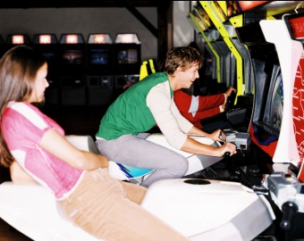

* 1 hour of undivided attention from family-member of choice: 300 points

C:\Users\jdhopkin\AppData\Local\Microsoft\Windows\Temporary Internet Files\Content.IE5\N1OIV8H1\MC900104714[1].wmf

* 10-minute back massage: 250 points



* A manicure: 200 points



* A book: 100 points



* Nail polish/lipstick: 100 points

C:\Users\jdhopkin\AppData\Local\Microsoft\Windows\Temporary Internet Files\Content.IE5\AQH31864\MC900389480[1].wmf

* A rose: 20 points



* Deposit into savings account (20 points = $1)



* Donation to Kiva project (20 points = $1)

C:\Users\jdhopkin\AppData\Local\Microsoft\Windows\Temporary Internet Files\Content.IE5\N1OIV8H1\MC900297531[1].wmf

The quests in this game come in the form of cleaning each of the rooms/living spaces to the specifications in the clean photos and checklists which Mom and Dad draft to ensure nothing is missed. Mom and Dad can use their discretion, but an example of quests and associated points is outlined on the next page.

**Quests:**

* Bathroom quest: 15 points

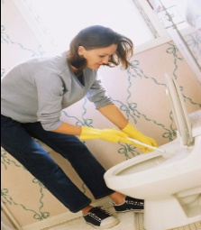

* Kitchen quest: 15 points



* Living room quest: 10 points

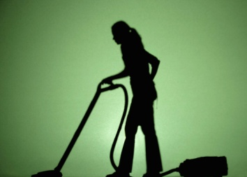

* Bedroom quest: 10 points

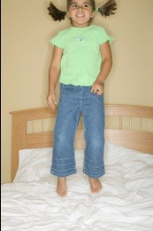

* Hallway quest: 5 points

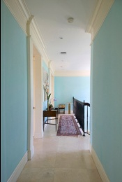

Step 6: Mom and Dad place pictures of perfectly clean rooms (aka win states) and checklists in a safe place in each room for reference.



Step 7: Mom and Dad create a giant quest log for prominent display in the home so that everyone can see who has done what and compete for the maximum amount of points. Parents may set maximum number of points for children who may become a bit overzealous with the exercise (say 800 points per month maximum).

C:\Users\jdhopkin\AppData\Local\Microsoft\Windows\Temporary Internet Files\Content.IE5\N1OIV8H1\MC900441517[1].wmf

**The Case for Gamification**

In our non-gamified scenario, we had one unhappy mom carrying all the burden and stress of making sure the house is clean and in order. With the gamification proposed above, other members of the household are motivated to take action and share in the responsibility, because they value the rewards that will be given to them if they complete the quests through a systematic points system.

To reference our textbook, John Ferrara also talks about the concept of competence and states “[m]ost people have experience the joy of a job well done…[t]here’s an intrinsic pleasure in the feeling of being really good at something.” (Ferrara, p. 42) In the gamified scenario above, household members can know they succeeded in completing each quest, because they can see what clean is and they have a checklist to verify all the points. Being able to check off all the items on the checklist results in a feeling of competence, which can serve to motivate.

In his same chapter on Player Motivations, Ferrara discusses how “[g]ames can offer people great accomplishment while putting them at no real personal risk.” (Ferrara, p. 42) Though in this case, Ferrara was likely talking to situations that are able to be played out in a game world, it is not untrue in our case as well. Everyone can pitch in without feeling like they had to. This combined with the fact that the public posting of each household member’s progress, which doubles as a tangible social image mechanism and a points system (Ferrara, p.128), can result in continuous victory for the whole family.

